Partner Toolkit

Overview
Thank you for your partnership of the 2021 AOCS Annual Meeting & Expo. With over 3,000 attendees expected, we look forward to an impactful, inclusive event. This toolkit includes messages you can use to let your contacts know you are a meeting partner and encourage them to attend.

We suggest you update the content below by highlighting specific sessions and events that you feel would be of interest to your network.

LinkedIn Event
Invite your connections to join you at the 2021 AOCS Annual Meeting & Expo! Here is how:

- Go directly to the 2021 AOCS Annual Meeting & Expo event using the URL https://www.linkedin.com/events/aocsannualmeetingandexpo6757402012461228032/

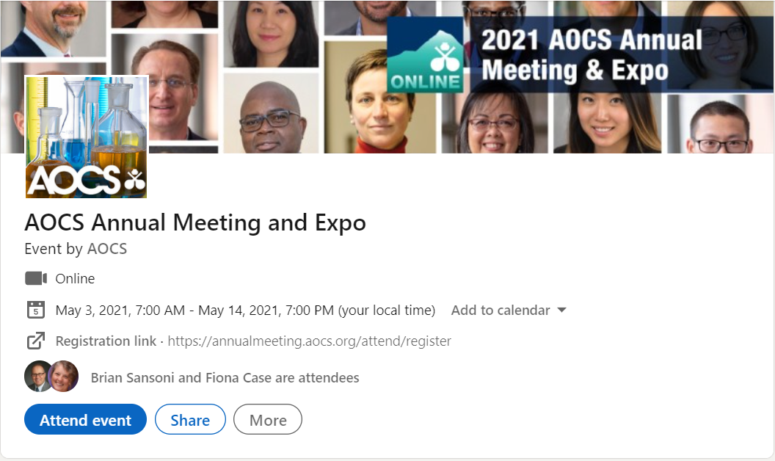

- In order to invite people in your network, you must already be RSVPed! Click the blue ‘Attend event’ button on the event listing.
- Once you are RSVPed, you will see a blue ‘Invite Connections’ button. Click to begin inviting your LinkedIn contacts to the AOCS Annual Meeting event.
- You are able to filter to make inviting your peers easy. You can:
  - Type a person’s name in the search field to find them specifically
  - Use the location, company or school filters to specify groups of connections to invite
- Select the checkbox next to the name of the connection(s) you want to invite.
- Click the blue ‘Invite’ button to send your Event invitations.

Email Copy
Please use the email copy below to reach out to your professional network and contacts. Feel free to personalize or modify the copy as much as you like.

Suggested subject line: Join me online at the 2021 AOCS Annual Meeting & Expo!

Greetings [insert first name],

[Organization name] is honored to be a partner of the online 2021 AOCS Annual Meeting & Expo, the largest global science and business forum on fats, oils, proteins, surfactants and related materials. Taking place from May 3–14, the meeting is designed to foster inclusiveness, allowing attendees to save time and travel expense with its convenient online format.

The interdisciplinary, in-depth technical program features hundreds of oral and poster presentations within 10 interest areas, including:

[Highlight several interest areas related to your organization from the list below]:

- Analytical
- Biotechnology
- Edible applications technology
- Health and nutrition
- Industrial oil products
- Lipid oxidation and quality
- Phospholipid
- Processing
- Protein and co-products
- Surfactants and detergents

I thought you would be interested in this opportunity to grow your scientific network and discover the latest innovations. I hope you will join [insert organization name] and more than 3,000 industry professionals at the 2021 AOCS Annual Meeting & Expo.

Learn more and register for the meeting today. We hope to see you online in May!

Best,

Social Media Posts
Get the word out on social and broaden your reach. A few sample posts are included here — feel free to personalize these.

- We are honored to partner with AOCS on the online 2021 AOCS Annual Meeting & Expo, taking place May 3–14. Join us at the largest global science and business forum on fats, oils, proteins, surfactants and related materials. Learn more and register today. annualmeeting.aocs.org/attend/register

- As a meeting partner, we invite you to join [company name] and more than 3,000 industry professionals online at the 2021 AOCS Annual Meeting & Expo from May 3–14! The meeting is designed to foster inclusiveness, allowing attendees to save time and travel expense with its accessible online format. Learn more: annualmeeting.aocs.org/attend/register

- We are proud to partner on the 2021 AOCS Annual Meeting & Expo, May 3–14. Join us from May 3–14 to engage on the latest in the science and technology of fats, oils, proteins, surfactants and related materials. annualmeeting.aocs.org/attend/register

- We are honored to partner with AOCS on the 2021 AOCS Annual Meeting & Expo, May 3–14. Join us online to learn, engage and connect with colleagues. Find out more and register today. annualmeeting.aocs.org/attend/register

- We are partnering with AOCS on the 2021 AOCS Annual Meeting & Expo! Join us online from May 3–14 to engage on the latest in the science and technology of fats, oils, proteins, surfactants and related materials. annualmeeting.aocs.org/attend/register

As partners of AOCS and the 2021 AOCS Annual Meeting & Expo, May 3–14, we invite you to attend. Participate online in 100+ live sessions and interactive discussions showcasing the latest research and innovations. annualmeeting.aocs.org/attend/register

