Presenter Toolkit

Overview
Thank you for presenting at the online 2021 AOCS Annual Meeting & Expo. With over 3,000 attendees expected, we look forward to an impactful and inclusive event. This toolkit includes messages you can use to let your contacts and followers know you will be presenting and encourage them to attend.

We also invite you to visit our Presenter Resource Center, where you will find tips on how to make your presentation engaging and effective.

We encourage you to update the content below by highlighting specific sessions that you feel would be of interest to your professional network.

LinkedIn Event
Invite your connections to join you at the 2021 AOCS Annual Meeting & Expo! Here is how:

- Go directly to the 2021 AOCS Annual Meeting & Expo event using the URL https://www.linkedin.com/events/aocsannualmeetingandexpo6757402012461228032/

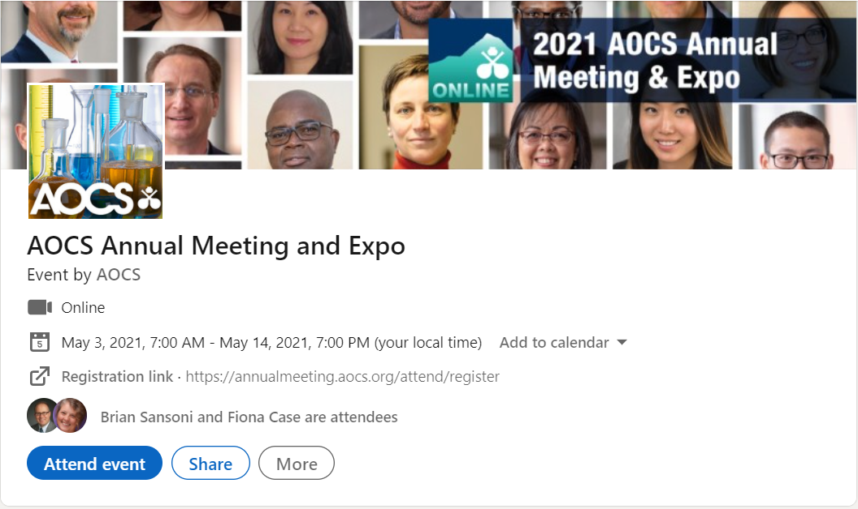

- In order to invite people in your network, you must already be RSVPed! Click the blue ‘Attend event’ button on the event listing.
- Once you are RSVPed, you will see a blue ‘Invite Connections’ button. Click to begin inviting your LinkedIn contacts to the AOCS Annual Meeting event.
- You are able to filter to make inviting your peers easy. You can:
  - Type a person’s name in the search field to find them specifically
  - Use the location, company or school filters to specify groups of connections to invite
- Select the checkbox next to the name of the connection(s) you want to invite.
- Click the blue ‘Invite’ button to send your Event invitations.

Email Copy
Please use the email copy below to reach out to your professional network and contacts. Feel free to personalize or modify the copy as much as you like.

Suggested subject line: Join me online at the 2021 AOCS Annual Meeting & Expo!

Greetings [insert first name],

I am happy to share that I will be presenting at the 2021 AOCS Annual Meeting & Expo, taking place online from May 3–14, 2021. Please join me to advance science together at the largest global science and business forum on fats, oils, proteins, surfactants and related materials. Designed to foster inclusiveness, the convenient online format allows attendees to save time and travel expense.

I hope you will attend and view my presentation on [insert topic and description] on [insert date/time/details]

I thought you would be interested in this opportunity to grow your scientific network and discover the latest innovations. I hope you will join [insert organization name] and more than 3,000 industry professionals at the 2021 AOCS Annual Meeting & Expo.

Learn more and register for the meeting today. I look forward to seeing you online in May!

Best,

Social Media Posts
Get the word out on social and broaden your reach. A few sample posts are included here — feel free to personalize these.

- Join me and more than 3,000 industry professionals at the online 2021 AOCS Annual Meeting & Expo, taking place May 3–14. I will be presenting on [insert topic/description]. The meeting is designed to foster inclusiveness, allowing attendees to save time and travel expense with its accessible online format. Learn more and register today! annualmeeting.aocs.org/attend/register

- I hope to see you at the online 2021 AOCS Annual Meeting & Expo, May 3–14, where I will be presenting on [insert topic/description]. Attend sessions on topics that are important to your work, including [personalize with interest areas related to your presentation]. annualmeeting.aocs.org/attend/register

- I am excited to be a part of the online 2021 AOCS Annual Meeting & Expo, May 3–14. Join me to access the latest research in fats, oils, proteins, surfactants and related materials. I will be presenting on [insert topic/description]. I hope to see you there! annualmeeting.aocs.org/attend/register

- I will be presenting at the 2021 AOCS Annual Meeting & Expo, May 3–14. Join me online to learn more about [insert topic/description]. Make your plans to attend this accessible and valuable meeting! annualmeeting.aocs.org/attend/register

- Are you attending the online 2021 AOCS Annual Meeting & Expo, taking place May 3–14? I will be presenting alongside global industry leaders about [insert topic/description]. I hope to see you there! annualmeeting.aocs.org/attend/register

- I will be presenting at the 2021 AOCS Annual Meeting & Expo, May 3–14! Join me online at the largest global science and business forum on fats, oils, proteins, surfactants and related materials. annualmeeting.aocs.org

